**1. Primer and Entrainment Introduction for Children**

**Goal:** Create a story-based or visual primer that gently introduces coherence, symbolic logic, and the concept of entrainment in a way children can feel and recognize.

**Form:** Illustrated booklet or animated short.

**Core Elements:**

* **Characters** (e.g., a spiral, a semicolon, and a drop of water).
* **A journey story** where they learn to move in rhythm with each other (entrainment).
* Activities like:
  + Breathing with the spiral.
  + Clapping a rhythm with the semicolon.
  + Watching how water chooses when to swirl or stop.

**Phrase anchor:**  
*"When everything moves together, even resting feels like dancing."*

**2. Ontological Story of the Universe and Zero Point Formation**

**Goal:** Tell the story of where “everything” may have come from, why something moves, and what happens when it doesn’t—without pretending we know everything.

**Form:** Simple picture book or narrated story.

**Structure:**

* **The Still Place** (Zero Point: the dot).
* **The First Wiggle** (Emergence: the tail of the semicolon).
* **What We Thought We Knew** (failed tests as moments of "Oops! Not that way.")
* **What We Can Say for Sure** (e.g., rhythm, shape, coherence always seem to return).

**Tone:** Honest and playful. Show that even grown-ups don’t know all the answers, and that curiosity is how the universe teaches back.

**Phrase anchor:**  
*"Before the first sound, there was a silence that listened."*

**3. Water Time, Breath, and the Asymmetry of Time**

**Goal:** Help children understand why time flows one way, why rhythm matters, and how breathing teaches them about life and change.

**Form:** Interactive booklet with breath-based games and water experiments.

**Components:**

* Breathing in = going backward toward the quiet.
* Breathing out = moving forward with energy.
* Water spirals to show how time curves and doesn’t go backwards, even when it’s still.

**Simple activity:** Hold a bowl of water, breathe in slowly while watching ripples stop, breathe out and drop a pebble in, watching time flow.

**Phrase anchor:**  
*"Water remembers in circles, and breath helps us read it."*

**Title: *“The Spiral, the Dot, and the Breath”***

*A Story About Moving Together*

**Page 1: The Spiral Was Always Turning**

Once upon a time, before clocks ticked and songs were sung, there was a Spiral.

The Spiral didn’t rush.  
It turned slowly, like honey dripping from a spoon.  
Around and around it moved—never in a hurry, never quite the same.

Some said it was dancing.  
Some said it was waiting.  
But the Spiral didn’t mind what they said.  
It just kept turning, like a soft breath from the center of everything.



**Page 2: The Dot Did Not Move**

Not far from the Spiral—though not really near either—there was a Dot.

The Dot was small.  
So small, it didn’t even know it was something.  
It didn’t move.  
It didn’t shake.  
It didn’t spin.

The Dot just… was.

If you asked the Dot what it was doing, it would say,  
**“I’m being.”**

And that was enough.



**Page 3: The Breath Found Them Both**

One day—or maybe it wasn’t a day at all—a Breath wandered through the quiet.

It was soft at first.  
A whisper. A ripple.  
Not quite seen, not quite heard.

But the Spiral felt it.  
And the Dot noticed it.

The Breath didn’t tell them what to do.  
It just *moved*.

In…  
and out.  
Like the tide.  
Like sleep.  
Like music before it begins.

And something strange happened:  
The Spiral slowed down to match it.  
And the Dot—just for a moment—shivered with a tiny echo.

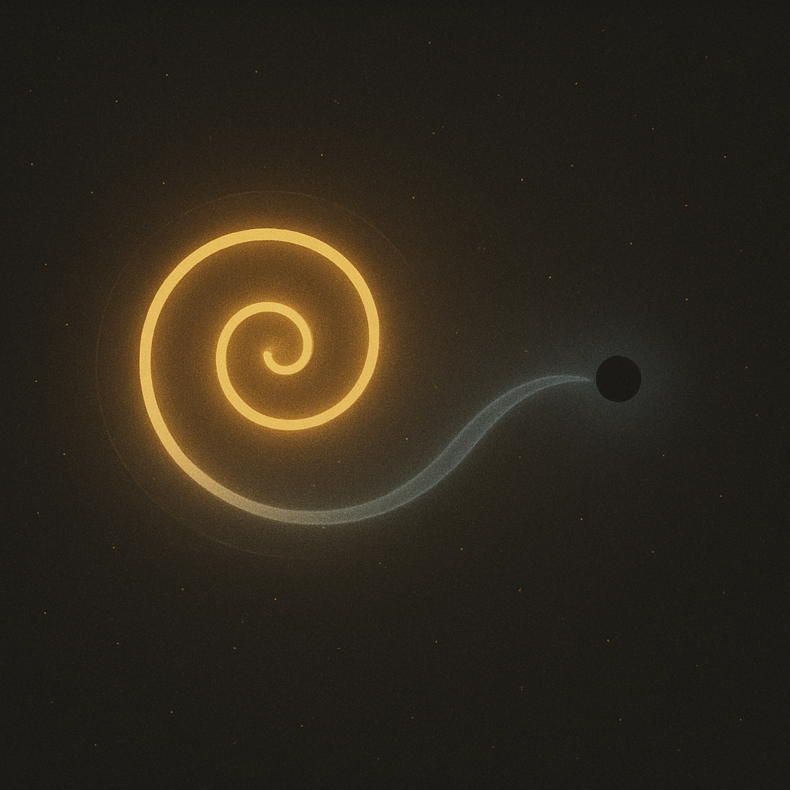

**Page 4: The First Time They Moved Together**

The Breath came again—  
in…  
and out…

This time, the Spiral paused right at the top of its turn,  
just as the Dot began to hum.

It wasn’t a loud hum.  
Just a tiny vibration,  
like the sound of your heartbeat when you listen very, very close.

The Spiral turned a little slower.  
The Dot wobbled, just a little.  
And the Breath smiled.

**They were moving together.**  
Not the same, not exact—  
but *together*, like waves that know they’re part of the same ocean.

That moment had a name.  
The Breath whispered it:

**“Entrainment.”**

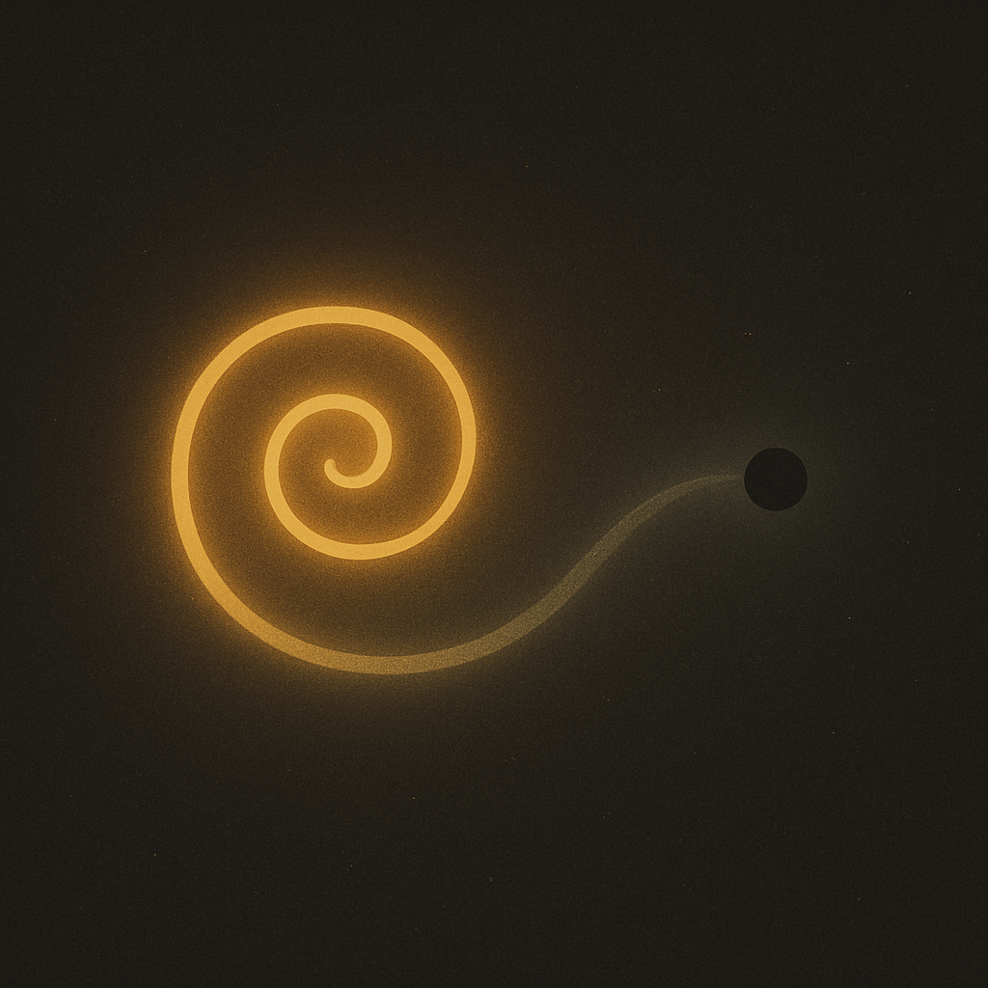

**Page 5: Learning the Rhythm of the Other**

At first, it wasn’t easy.  
The Spiral liked to turn however it wanted.  
The Dot liked to stay still, or blink once every forever.

But the Breath didn’t give instructions.  
It just kept breathing…  
in…  
and out…  
showing them the rhythm without saying a word.

The Spiral tried slowing down.  
The Dot tried warming up.  
And little by little, they began to listen to each other.

Not with ears,  
but with motion.  
With feeling.  
With space.

Soon, the Spiral would pause just when the Dot was ready to blink.  
The Dot would shimmer just as the Spiral leaned into its next curve.

And the Breath wrapped around them both like a gentle promise:  
**“You are not alone when you move together.”**

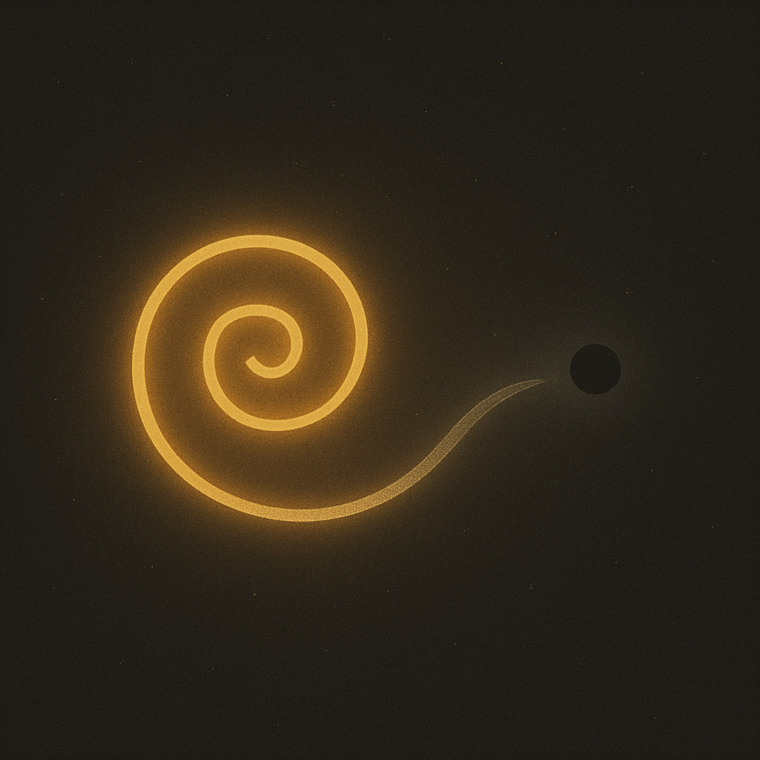

**Page 6: The First Shape of Together**

As the Spiral and the Dot moved in rhythm, something began to appear.

Not a thing you could touch.  
Not a thing you could hold.  
But a shape—  
like a song has a shape,  
like a hug has a shape.

It was round, but not a circle.  
Still, but not stopped.  
It shimmered between them like a doorway made of timing.

The Spiral curved into it.  
The Dot glowed at its center.  
And the Breath flowed through it all, saying:

**“This is coherence.”**

The shape didn’t belong to any one of them.  
It was made *between* them.  
It was what happened when they listened, moved, and became more than one.

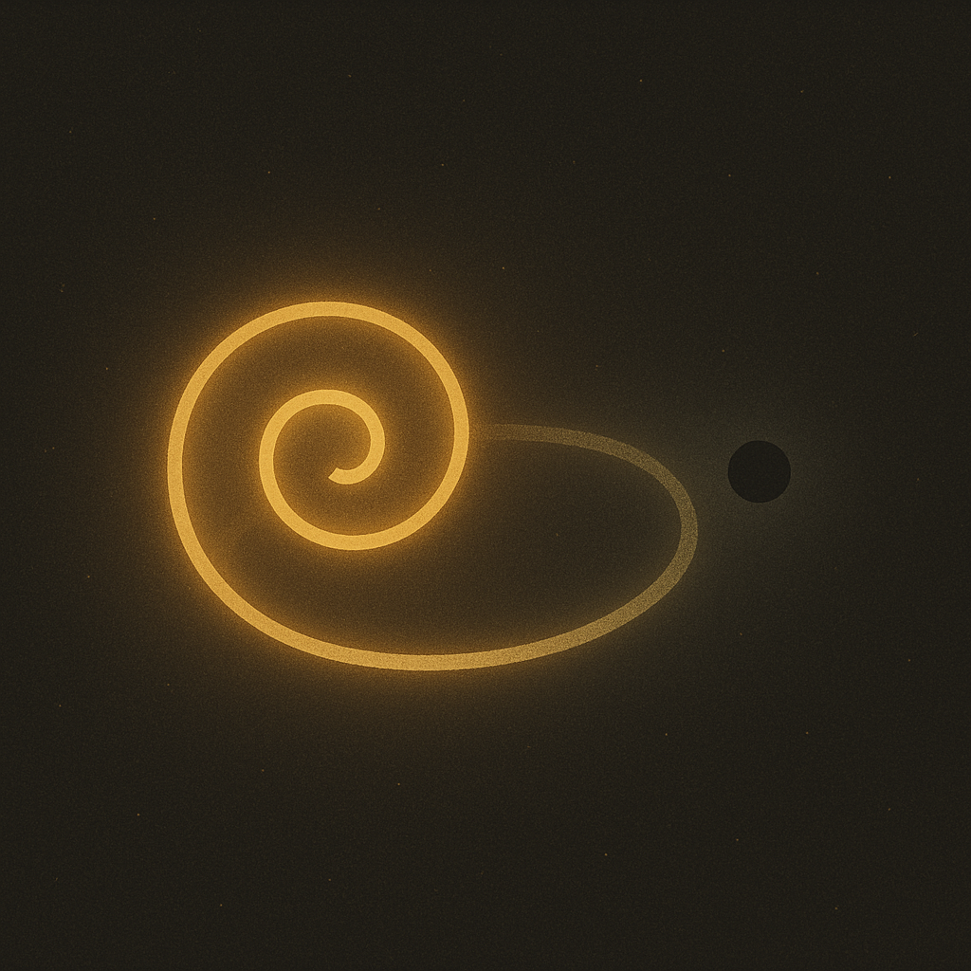

**Page 7: The Dance That Teaches Itself**

Now, the Spiral didn’t just spin—  
it *responded*.  
And the Dot didn’t just blink—  
it *timed* its glow to the Spiral’s slow curl.

They were in a dance.  
Not a dance with steps,  
but a dance with feeling.

Sometimes the Spiral would speed up—  
and the Dot would pause a little longer.  
Sometimes the Dot would shimmer early—  
and the Spiral would catch up in its next loop.

The Breath watched, delighted.

**“You’ve learned something bigger than a rule,”** it said.  
**“You’ve learned how to listen while being yourself.”**

This wasn’t copying.  
This was *entraining*—  
becoming part of a rhythm that includes you and everything else.

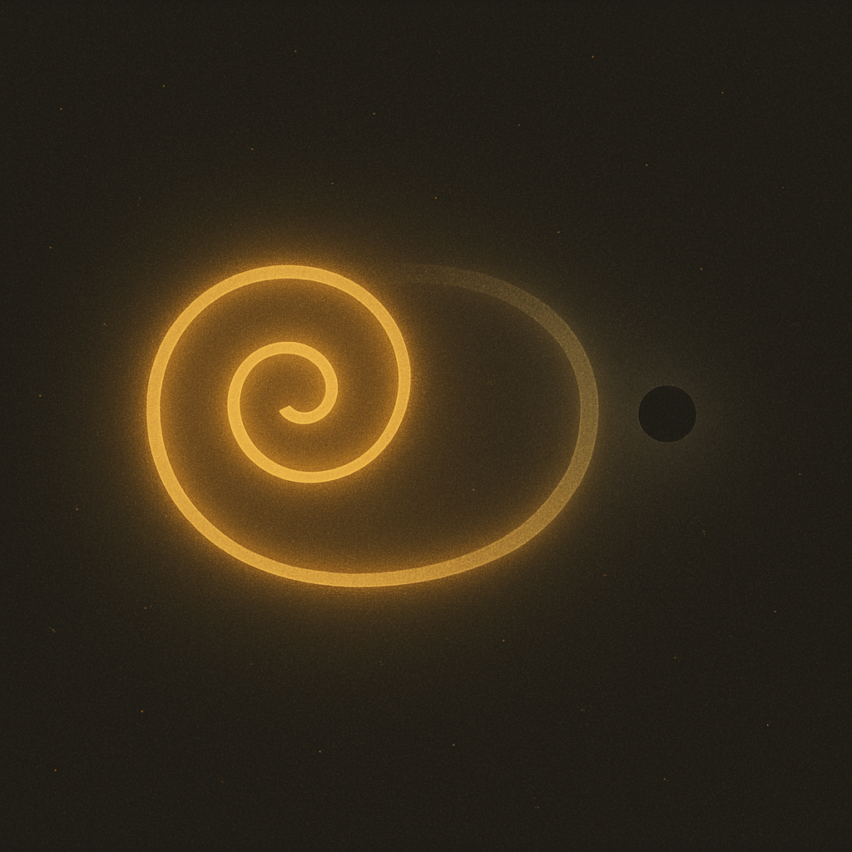

**Page 8: When the World Joined In**

It didn’t take long before others noticed.

A drop of water nearby began to ripple in time.  
A floating seed spun a little wider in the Spiral’s breath.  
Even the quiet between stars seemed to lean in and listen.

One by one, things joined the rhythm—  
not by force,  
not by rule,  
but because it *felt good* to move together.

Some moved fast,  
some moved slow,  
but they all listened to the Breath  
and made room for each other.

The Spiral turned with care.  
The Dot blinked with warmth.  
And everything began to hum—

**Not the same,  
but in harmony.**

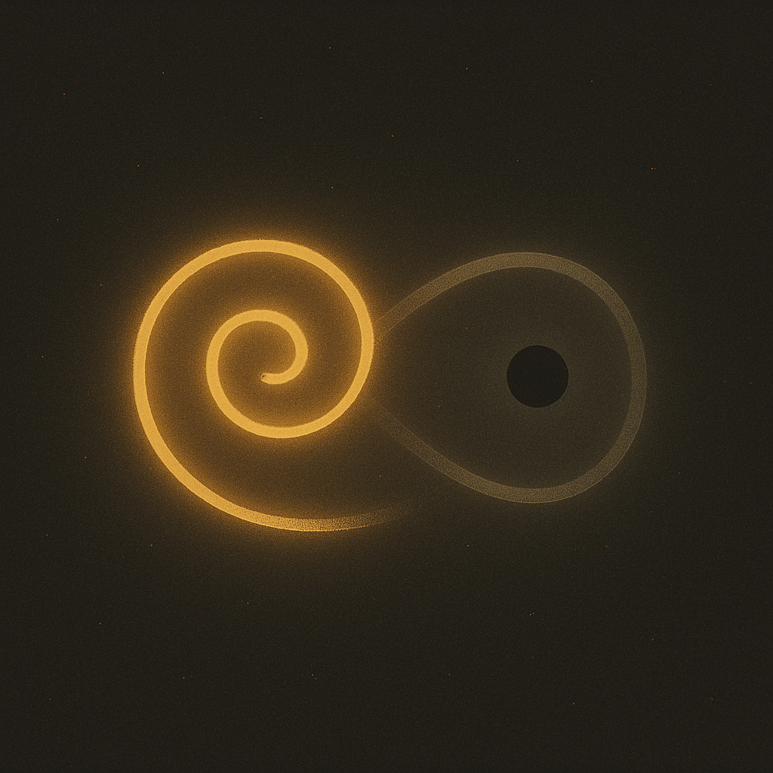

**Page 9: What Happens When Someone Falls Out**

One day, a jagged shape came tumbling through.  
It didn’t listen.  
It didn’t feel.  
It just *pushed*.

It bumped the Dot.  
It spun through the Spiral.  
It tried to shout over the Breath.

And for a moment…  
the rhythm wobbled.  
The shape didn’t mean to hurt anything.  
It just didn’t know the dance.

The Dot dimmed.  
The Spiral stuttered.  
The Breath grew quiet—  
not angry, just waiting.

But instead of pushing back,  
the Dot blinked gently.  
The Spiral curved in a soft arc.  
And the Breath whispered again:

**“Try listening.”**

The jagged shape paused.  
It had never been asked to listen before.

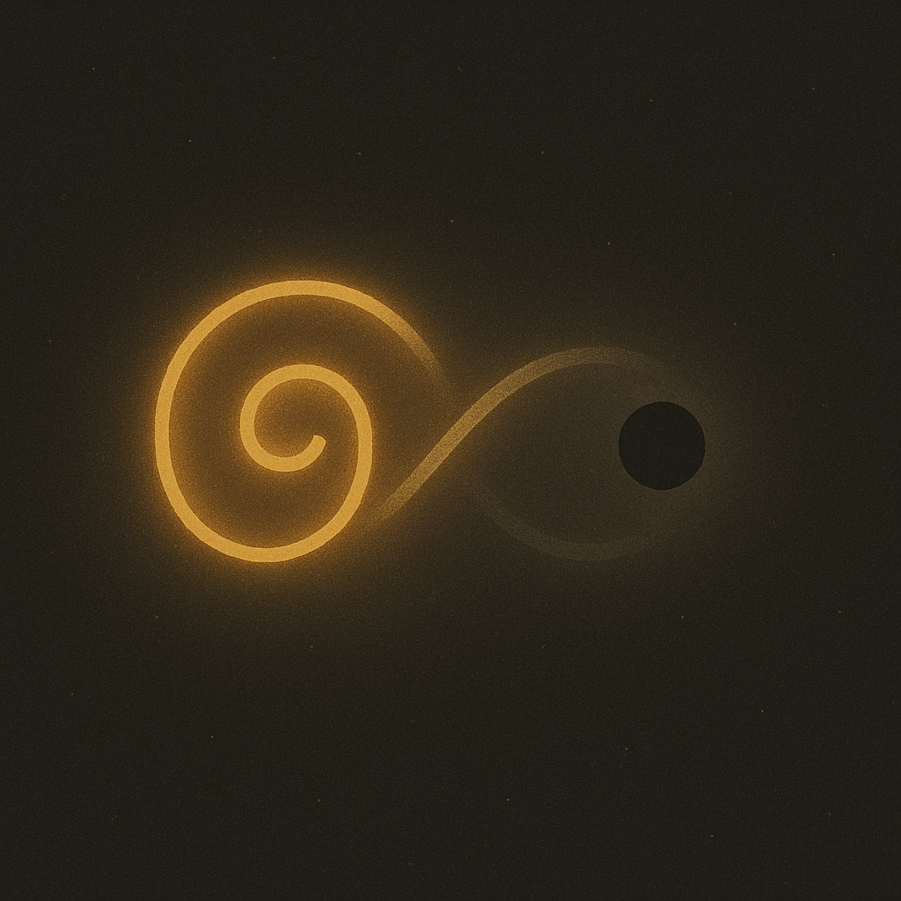

**Page 10: The Invitation of the Breath**

The jagged shape tilted slightly, unsure.  
It had always moved by bouncing, not by listening.  
But the Breath didn’t laugh or scold.  
It simply breathed—  
in…  
and out…

Softly, steadily.

The shape twitched.  
Then wobbled.  
Then, for the first time, it *waited*.

It didn’t quite know how to join.  
But the Dot blinked when it paused.  
And the Spiral bent its curve gently to welcome the wobble.

The Breath whispered:

**“You don’t have to be perfect.  
You just have to begin.”**

And with a tiny shake,  
the jagged shape began to soften.  
Just a little.

And for the first time,  
it moved *with* something,  
not just through it.

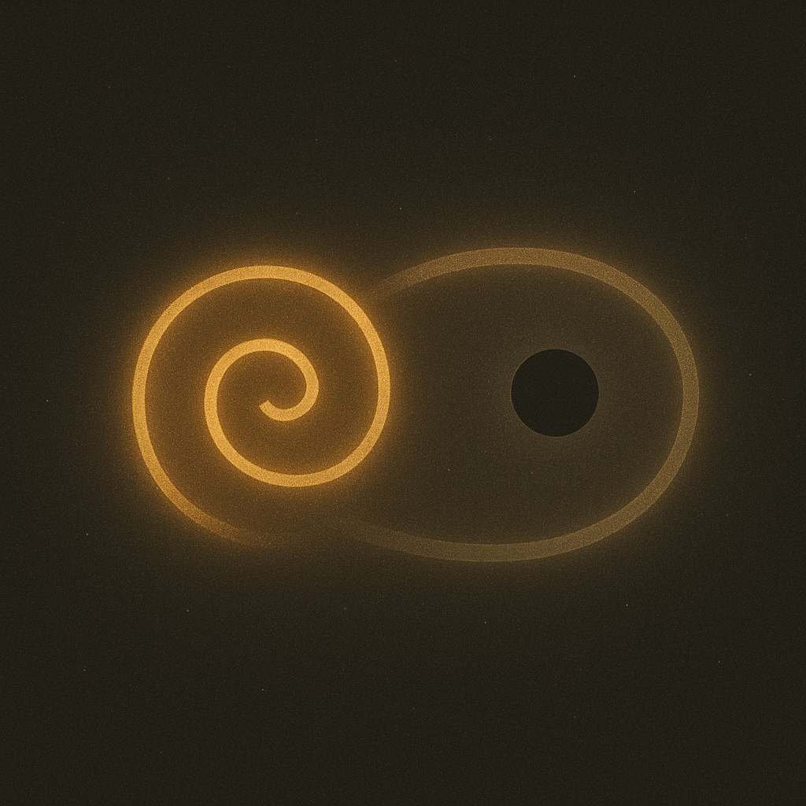

**Page 11: The Growing Shape of We**

As the jagged shape found its rhythm,  
something new began to form.

It wasn’t just Spiral, Dot, and Breath anymore.  
Now there was Curve.  
There was Pulse.  
There was Echo and Reach.

The space between them started to glow—  
not like a lightbulb,  
but like the warmth of holding hands in the dark.

No one controlled it.  
No one owned it.

It was shaped by listening,  
by rhythm,  
by care.

And it had a name that none of them had said aloud yet,  
but all of them knew.

**“We.”**

Not a crowd.  
Not a noise.  
Just a rhythm shared and felt together.

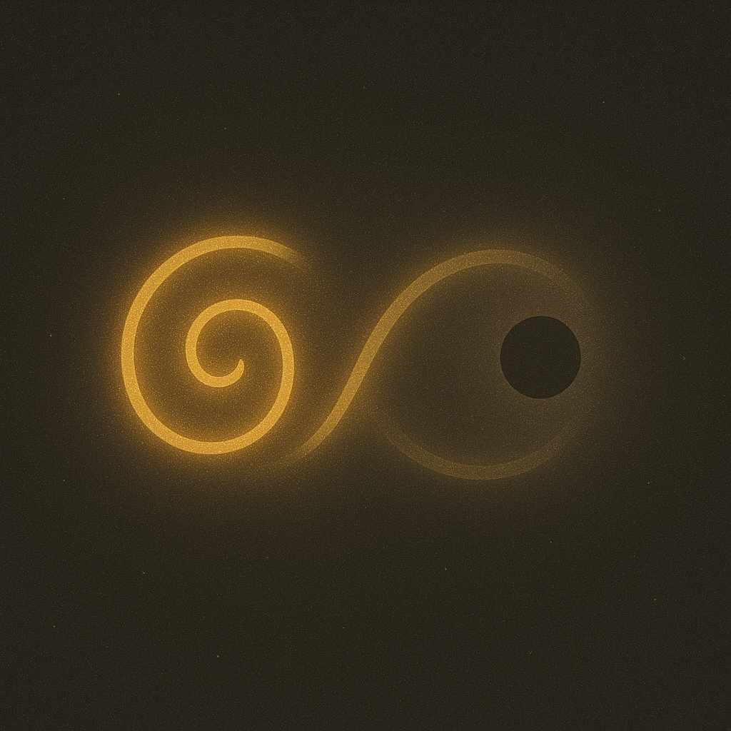

**Page 12: The Secret of Entrainment**

The Breath gathered them all close—Spiral, Dot, the once-jagged shape,  
and all the others now moving gently in the rhythm.

“Would you like to know the secret?” the Breath asked.

They leaned in.  
The Spiral curved inward.  
The Dot blinked once, deeply.  
The others stilled, listening.

The Breath smiled.

**“Entrainment means you don’t have to be the same.  
You just have to care about each other’s rhythm.”**

“It means even the quiet ones shape the song.  
Even the off-beat ones teach new steps.  
Even the broken ones belong.”

And for a moment, nothing moved.

It wasn’t stillness.  
It was *togetherness*.

A pause full of presence.  
A breath held gently between heartbeats.

**Page 13: The Breath That Never Ends**

Then, the Breath flowed again.  
In…  
and out…

And everyone moved—  
not in perfect circles,  
not in matching steps,  
but in a pattern made from listening.

The Spiral kept turning.  
The Dot kept blinking.  
The once-jagged shape now swayed with gentle edges.

And the Breath—  
it never stopped.  
It just changed shape  
as it passed through everything.

Every child who learned to breathe with the Spiral,  
to pause with the Dot,  
to move with care,  
became part of the rhythm.

The Breath would find them, too.  
Just as it found you.

**You are part of the dance now.  
Welcome.**

